What steps need to be done before performing surface–volume registration?

Before performing surface–volume registration, several preprocessing steps are required in the Anatomical Pipeline of the BrainSuite BIDS Workflow.
The Anatomical Pipeline processes T1-weighted MRI (T1w BIDS) data to extract detailed structural information of the brain. It prepares the anatomical foundation necessary for subsequent diffusion and functional MRI analyses.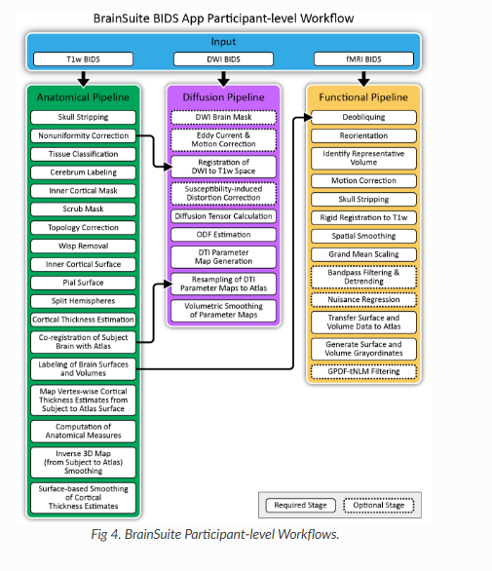

Step 1: Skull Stripping
Why we use it:
Removes non-brain tissues such as scalp, skull, eyes, and neck fat to isolate only the brain structures.
Outcome:
A clean brain-only image that can be used for tissue segmentation and surface extraction.

Step 2: Nonuniformity Correction
Why we use it:
MRI images often have intensity inhomogeneities (bias fields) caused by scanner imperfections. This step corrects those variations.
Outcome:
Uniform intensity throughout the brain image, improving the accuracy of tissue classification.

Step 3: Tissue Classification
Why we use it:
Segments the brain image into Gray Matter (GM), White Matter (WM), and Cerebrospinal Fluid (CSF).
Outcome:
Tissue probability maps — essential for structural analysis and cortical modeling.

Step 4: Cerebrum Labeling
Why we use it:
Identifies and labels anatomical regions in the cerebrum based on structural boundaries.
Outcome:
Labeled atlas of brain regions (e.g., frontal, parietal, temporal lobes).

Step 5: Inner Cortical Mask
Why we use it:
Creates a mask along the gray–white matter boundary to guide cortical surface extraction.
Outcome:
Accurate delineation of the inner cortical surface.

Step 6: Scrub Mask
Why we use it:
Removes spurious regions or residual non-brain voxels that may affect surface generation.
Outcome:
Refined brain mask, free of unwanted signals or artifacts.

Step 7: Topology Correction
Why we use it:
Ensures that cortical surfaces are topologically correct (no holes or disconnected regions).
Outcome:
Continuous and topologically valid cortical surface mesh.

Step 8: Ventricle and White Matter (WMS) Removal
Why we use it:
Eliminates internal structures (like ventricles) that are not part of the cortical mantle.
Outcome:
Clean surface model of the cortex.
Step 9: Inner Cortical Surface Extraction
Why we use it:
Generates the boundary between white and gray matter (inner cortical surface).
Outcome:
3D mesh representing the inner cortical surface.

Step 10: Pial Surface Extraction
Why we use it:
Creates the outer boundary between gray matter and cerebrospinal fluid (CSF).
Outcome:
3D pial surface model of the cortex.

Step 11: Split Hemispheres
Why we use it:
Separates the brain into left and right hemispheres for individual analysis.
Outcome:
Independent left and right hemisphere surface models.

Step 12: Cortical Thickness Estimation
Why we use it:
Measures the thickness of the cortex between the inner and outer cortical surfaces.
Outcome:
Cortical thickness maps — useful for studying aging, neurodevelopment, or neurological disorders.

Step 13: Co-registration of Subject Brain with Atlas
Why we use it:
Aligns the subject’s brain to a standard atlas (e.g., MNI) for group or population studies.
Outcome:
Atlas-aligned brain data ready for cross-subject comparison.

Step 14: Labeling of Brain Surfaces and Volumes
Why we use it:
Applies atlas-based labels to both the surface and volume structures.
Outcome:
Region-wise labeled surfaces and volumes for quantitative analysis.

Step 15: Map Vertex-wise Cortical Thickness from Subject to Atlas Surface
Why we use it:
Transfers individual thickness maps to a common atlas for group analysis.
Outcome:
Standardized cortical thickness maps.

Step 16: Computation of Anatomical Measures
Why we use it:
Calculates measures such as cortical volume, surface area, curvature, etc.
Outcome:
Quantitative metrics describing individual brain morphology.

Step 17: Inverse 3D Map from Subject to Atlas
Why we use it:
Creates a reverse mapping to transform atlas-based results back to the subject’s native space.
Outcome:
Bidirectional mapping between subject and atlas space.

Step 18: Surface-based Smoothing of Cortical Thickness Estimates
Why we use it:
Smooths thickness maps to reduce noise and prepare for statistical comparison.
Outcome:
Smoothed cortical thickness data ready for group-level statistical analysis.

In summary, these preprocessing steps transform raw T1-weighted MRI data into clean, anatomically accurate, and standardized cortical models, forming the essential foundation for surface–volume registration and advanced functional or diffusion MRI analyses.

